Cost-effectiveness of Esketamine versus Alternative Treatment Strategies for Treatment-resistant Depression in Hong Kong: A Multi-armed Modelling Study

Research Protocol
- INTRODUCTION
  - Background
Although antidepressants have been the important treatment modalities to manage major depressive disorder, more than half of patients who suffer from depression do not respond to their first trial of antidepressants, and significant proportions of patients remain non-responsive to subsequent lines of antidepressants. This condition is known as “treatment-resistant depression” (TRD). Current literature has demonstrated that patients with TRD had further increased risk of mortality, somatic and mental comorbidities, and economic burden compared to treatment-responsive depression. Below 20% of depression patients develop treatment resistance, but they have been projected to account for up to 41% of costs of care in the entire depression population, therefore serving as the source of the immense economic burden in depression. Common strategies to manage TRD include switches between antidepressants, augmentation or combination of current therapy with other antidepressants or antipsychotics. However, these strategies are unlikely to improve disease outcome if the patients remain physiologically unresponsive to antidepressants.

In recent years, a novel medication called esketamine (Spravato) was approved by the United States in 2019 and by Hong Kong in 2021. Esketamine, which is the S-enantiomer of ketamine, serves as an N-methyl-D-aspartate (NMDA) receptor antagonist to activate α-amino-3-hydroxy-5-methylisoxazole-4-propionic acid (AMPA) and boost the release of brain-derived neurotrophic factor (BDNF), a crucial molecule that restores synaptic health. The remaining pathways are yet fully understood. Different from conventional oral antidepressants, esketamine is administered intranasally with rapid onset of action. Compared with oral antidepressants alone, Phase III trials have shown that esketamine adjunctive to oral antidepressant significantly reduced the severity score of depression after four weeks of treatment, with immediate change as early as within the second day which continued for 28 days, in contrast to the onset time of two to four weeks of oral antidepressants. In terms of long-term use, Phase III trials have highlighted that continued treatment of esketamine among those with response prolonged the time until relapse by 7.5 weeks, with only 27% of patients having experienced relapse (45% in the control). Common adverse events include nausea, headache, dizziness, dissociation, somnolence, and nasopharyngitis, but there has been no new safety signal for patients who remain in long-term maintenance treatment (up to 4.5 years).

  - Research Gaps
Despite the favourable effectiveness and safety profile, esketamine hits the market with a high price. Ross et al. have modelled the cost-effectiveness of intranasal esketamine in adjunct to oral antidepressant compared to using oral antidepressant alone in the United States. It was found that treatment was unlikely to be cost-effective unless the price of esketamine fell by 40% although the model showed incremental benefit in terms of time in remission following treatment each month. Five other modelling studies in the United States, Italy and Canada also gave similar conclusions when comparing esketamine to oral antidepressants, intravenous ketamine, and electroconvulsive therapy (ECT). Given the price up to US$5,000 per month, it is reasonable that the health and economic benefits brought by the medication might be outweighed by the additional costs of treatment and adverse events. Although it can be self-administered, patients must also be supervised by healthcare professionals during treatment as it is classified as a Schedule III Controlled Substance and dissociative side effects, which further raises the caring cost for clinical monitoring. Economic evaluation will be important to evaluate the cost-effectiveness of esketamine to inform formulary listing decisions in the healthcare system.

However, the existing cost-effectiveness studies had several limitations:
- Oral antidepressant alone is not a realistic comparator. Based on the clinical guidelines and treatment pathway research, oral antidepressant monotherapy was not the mainstay of treatment among TRD patients who already failed two lines of treatment. Of all pharmacological treatments for TRD in the real world, oral antidepressant monotherapy only accounts for 42% of the choices, as the severe ones also tend to have combination/augmentation therapies (42%) or polytherapy (16%). In reality, the use of non-pharmacological choices are also common. The comparison against choices other than oral antidepressant is inadequately studied but still of economic interest.
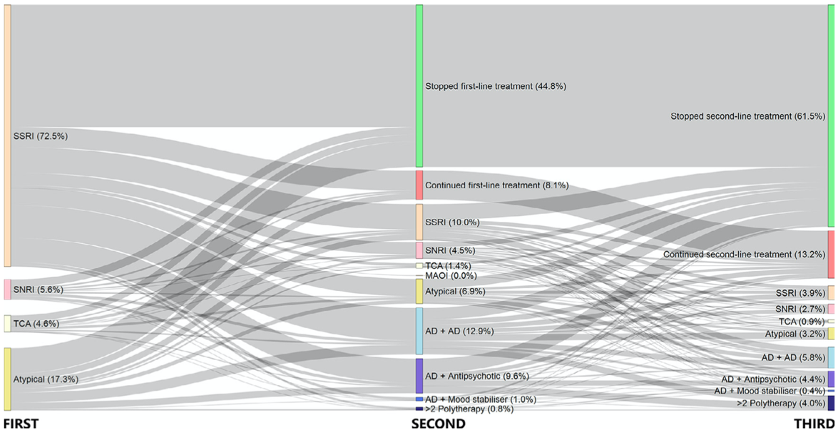
- Heavy reliance on clinical trial data source. In the United Kingdom, the NICE technology appraisal committee criticizes that the existing esketamine trials have limited generalizability to the actual clinical practice due to exclusion of patients with baseline psychiatric comorbidities, alcohol dependence, suicidal ideation in the previous 6 months, receiving deep brain stimulation or non-response to 7 lines of treatment with ECT. Whilst treatment resistance could correlate with increased potential for psychiatric comorbidities and suicidal intent, evidence gathering in the real world is needed to complement the trial findings.

  - Objectives
The abovementioned research gaps render a further investigation into the economic value of esketamine valuable, while addressing realistic comparators and scenarios that model real-world effectiveness and cost-effectiveness. In accordance with the NICE technology appraisal discussion (Section 3.3 and 3.6), we chose augmentation therapy as the reference comparator. In real-world clinical practice, patients with TRD are typically offered augmentation therapy following two unsuccessful antidepressant treatments. This study aims to:
- Assess the cost-effectiveness of esketamine nasal spray compared with six real-world usual comparators from the healthcare payer perspective;
- Identify the most cost-effective real-world treatment strategy for TRD management.

- METHODS
  - Study Population
A hypothetical cohort of patients with TRD above 18 years old with mean age of 49.5 (SD: 17.2) and 74.6% female patients. The demographics were referenced from the Hong Kong CDARS database, from which a real-world cohort who was newly diagnosed with depression between 2014 and 2016 and developed TRD afterwards has been extracted. TRD was defined as the failure of at least two antidepressant-based regimens or two treatment switches with the presence of the third regimen to confirm previous treatment failures, given adequate dosage, duration and adherence.

  - Model Design
This will be a Markov cohort model with six health states that estimates the cumulative costs and QALYs associated with esketamine versus other comparators. The states are:
- Treatment initiation: Initial period with any comparator treatment for 4 weeks.
- Remission: Resolution of symptoms with MADRS score at or below 12.
- Response: Partial remission with MADRS score improvement by 50%.
- Relapse: Recurrence of symptoms after remission or response.
- Non-response: Not reaching either remission or response after initial treatment.
- All-cause death: Observable death events regardless of causes.

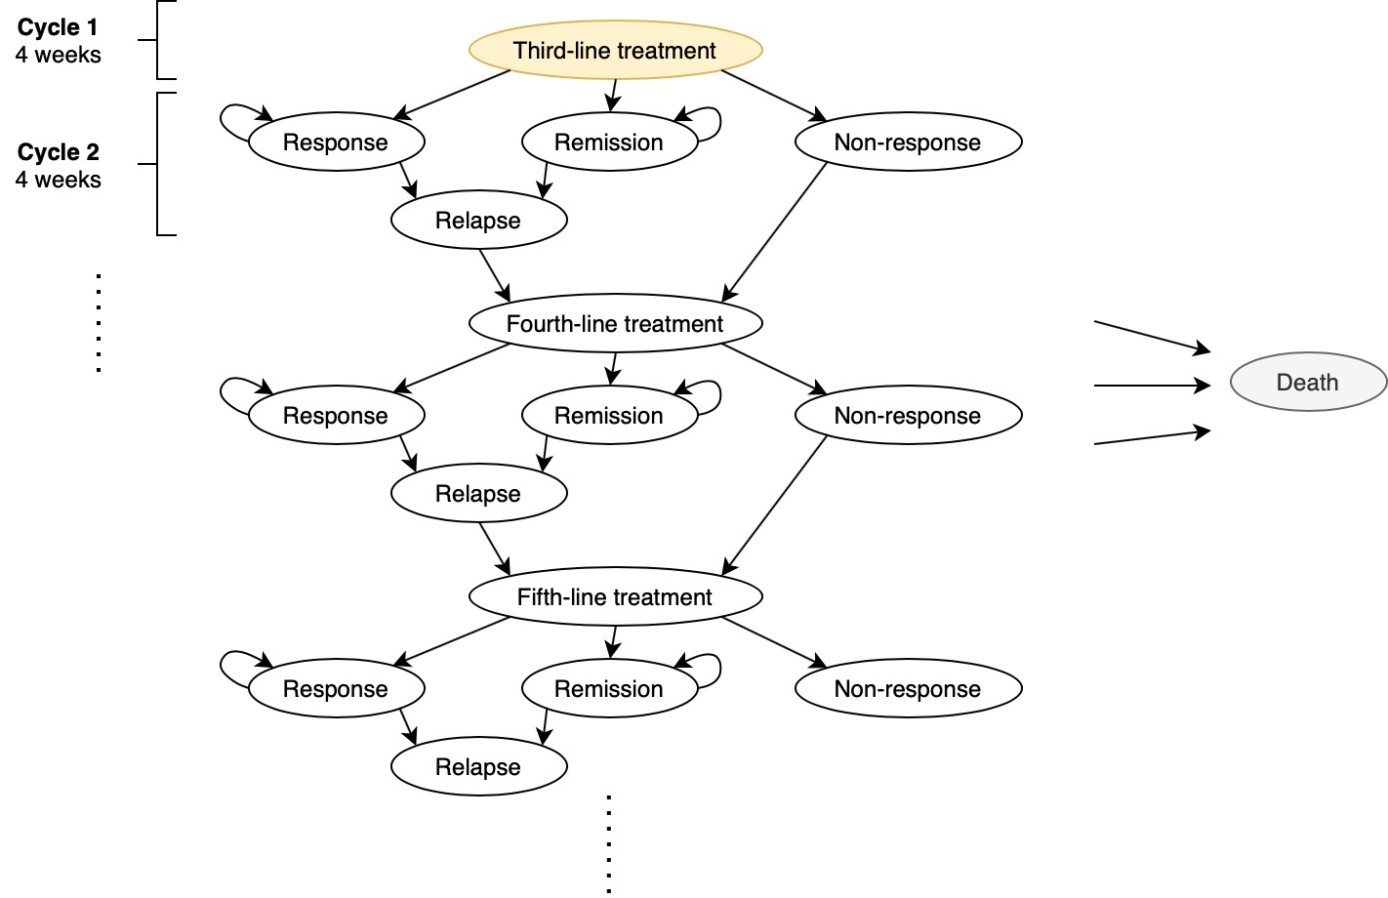

  - Model Setting
- Time Horizon: 5 years, which ensures enough time to accrue long-term costs but not excessively extrapolating the effectiveness estimates. Five years correspond to the maximum duration counting from 2019, the first approval date, and are sufficient to cover the maximum length of follow-up in current trials (i.e. 24 months).
- Perspectives: Healthcare payer
- Setting: Hong Kong public healthcare system
- Discounting: 3%, which corresponds to the projected inflation rate in Hong Kong
- Cycle Length: 4 weeks, which correspond to the minimum recommended treatment duration for patients with depression in each regimen.

  - Comparison Arms
- Augmentation treatments (referent)
  - Oral AD + Antipsychotics (Olanzapine, Cariprazine, Quetiapine, Ziprasidone) or Lithium
- Oral AD + Esketamine (key study arm)
- Combination treatments
  - Oral AD + oral AD
- Psychological treatments
  - Cognitive behavioural therapy (CBT)
  - Interpersonal therapy (IPT)
  - Dialectical behavior therapy (DPT)
  - Any of the above 3 strategies + Oral AD
- Neuromodulating treatments
  - Electroconvulsive therapy (ECT, inpatient only) + Oral AD
  - Repetitive transcranial magnetic stimulation (rTMS, ambulatory care) + Oral AD
The treatment should be initiated at the third line, i.e. once patients fulfill the TRD status and enter the model. When the third-line treatment fails, the relapsed and non-responsive patients will switch to other usual care based on the STAR*D trial (starting from level 2).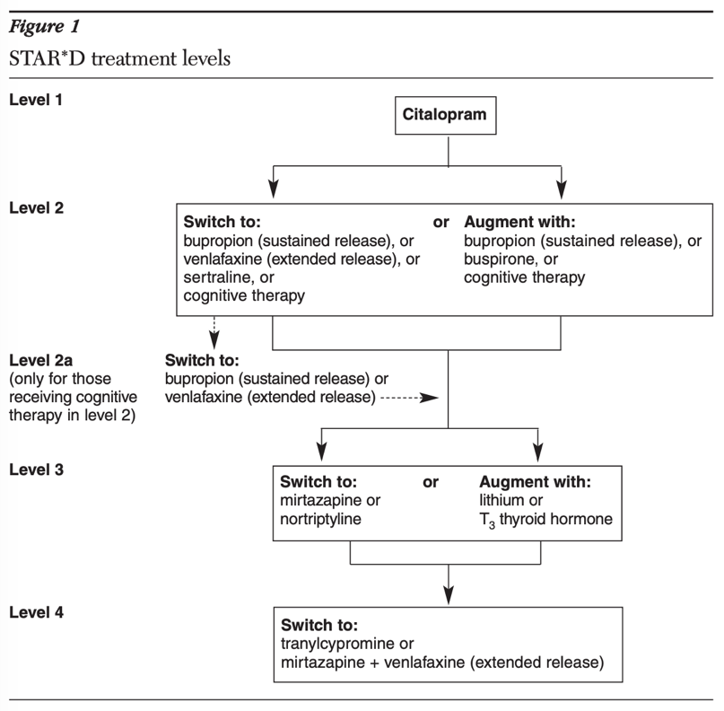

    - Targeted literature search
      - Effectiveness input parameters
Effectiveness input parameters regarding various treatment comparisons will be based on rapid systematic literature search, screening and review on PubMed using keywords: “treatment-resistant depression” AND (“esketamine” OR “combin*” OR “augment*” OR (“cognitive behavio*” AND “therap*”) OR “interpersonal therap*” OR (“dialectical behavio*” AND “therap*”) OR “electroconvulsive therap*” OR “transcranial magnetic stimulation”) AND (“effectiveness” OR “efficacy”) in all fields without language and date restriction, update to 9 May 2024. Inclusion criteria are systematic reviews, meta-analyses, clinical trials and original observational studies that report findings of comparative effectiveness (response, remission, symptom improvement etc.) about the treatment strategies listed in Section 2.4. Non-English records, narrative reviews, protocols, guidelines, preclinical studies, case reports and articles without full texts are excluded. The final choice of referencing literature will be consistent with the evidence pyramid (synopsis, then meta-analysis, then RCTs etc.), date of publication and relevant to the PICO of the current study. For the effectiveness of oral AD (referent arm), the primary reference will be the STAR*D trial.

      - Utility input parameters
Given that utility data were not consistently reported in the clinical trials of the interventions included in our analysis, we will source health-related quality-of-life (HRQoL) values from literature, which assessed the HRQoL of patient subgroups (remitters, responders, non-responders) in the most consistent context with the health states set in our model. The utilities of treatment initiation and relapse states will be assumed to be the same as that for non-response.

      - Cost input parameters
Treatment costs will be derived from three primary sources: internal data, published meta-analyses and list of private service charges from Hospital Authority. Healthcare resource utilisation (HRU) costs — including specialist outpatient clinic (SOPC), inpatient psychiatric hospital, and procedure-related services — will be based on unit costs listed from Hospital Authority for non-eligible persons.

  - Cost-effectiveness Analysis
Costs will be defined as the cumulative projected costs per strategy, including healthcare resource utilization costs, drug costs, and monitoring costs. Effectiveness will be defined as QALYs. All treatment strategies will be ranked based on expected costs in ascending order. Incremental costs, incremental effectiveness, and incremental cost-effectiveness ratios (ICERs) will be calculated against the augmentation therapy (referent), esketamine, and next non-dominated strategy. A cost-effectiveness plane will also be plotted with the reference group as the origin, to visually compare the incremental costs and effectiveness across different strategies.

ICER = (Cost_{a} – Cost_{b}) / (QALY_{a} – QALY_{b})

A cost-effectiveness acceptability curve (CEAC) will be plotted to illustrate which of the strategies will have the highest chance to be cost-effective under different willingness-to-pay thresholds. Value-based price estimates will be calculated for each strategy under different thresholds.

One-way deterministic sensitivity analysis (DSA) will be performed by varying each parameter to its lower and upper ranges and observe the differences in outcomes while keeping other parameters constant. A tornado diagram will be plotted to illustrate the ranking of parameters based on their influence on outcomes. A probabilistic sensitivity analysis (PSA) will also be conducted by varying all parameters simultaneously based on their assigned natural distributions with Monte Carlo simulation of 10,000 iterations. Results will be plotted against the cost-effectiveness plane, which will conclude the likelihood of being cost-effective.

  - Scenario Testing
The following scenarios of esketamine arm may be tested to explore uncertainties around clinical real-world esketamine use and cross-validate the main analysis:
- reducing dosing frequency from once weekly to biweekly after week 9;
- extending clinical follow-up intervals from four to eight weeks;
- substituting Specialist Outpatient Clinic and psychiatric day hospital costs with direct intranasal administration and monitoring costs;
- reducing each esketamine dose from 84 mg to 56 mg;
- applying a 3.5% annual discount rate to both costs and health outcomes, in line with UK NICE reference-case guidance;
- assuming a 75% reduction in the esketamine acquisition price to reflect potential future price negotiations or generic entry;
- extending the analytic time horizon from five years to a lifetime horizon (20 years) to assess the impact of truncating long-term costs;
- estimating the total esketamine arm cost required for esketamine to achieve cost-effectiveness at a WTP threshold of USD 50,000 per QALY.

- Ethics Approval and Funding
The study has obtained ethics approval from the Institutional Review Board (IRB) of The University of Hong Kong / Hospital Authority Western Cluster (UW20-218). Informed patient consent is not required as the retrospective real-world data source contains only anonymous information. The study is supported by the Hong Kong University Grants Committee Research Impact Fund (reference number: R7007-22). The funding source has no role in the study design, in the collection, analysis and interpretation of data, in the writing of manuscript and in the decision to submit the paper for publication.

- Remarks
References to support non-significant difference in relapse rates between antidepressants, combination and augmentation treatments:
- Mohamed S, Johnson GR, Chen P, et al. Effect of Antidepressant Switching vs Augmentation on Remission Among Patients With Major Depressive Disorder Unresponsive to Antidepressant Treatment: The VAST-D Randomized Clinical Trial. JAMA. 2017;318(2):132-145. doi:10.1001/jama.2017.8036
- Alexopoulos GS, Canuso CM, Gharabawi GM, et al. Placebo-controlled study of relapse prevention with risperidone augmentation in older patients with resistant depression. Am J Geriatr Psychiatry. 2008;16(1):21-30. doi:10.1097/JGP.0b013e31813546f2
- Rapaport MH, Gharabawi GM, Canuso CM, et al. Effects of risperidone augmentation in patients with treatment-resistant depression: Results of open-label treatment followed by double-blind continuation [published correction appears in Neuropsychopharmacology. 2006 Nov;31(11):2514] [published correction appears in Neuropsychopharmacology. 2007 May;32(5):1208]. Neuropsychopharmacology. 2006;31(11):2505-2513. doi:10.1038/sj.npp.1301113
- Lenze EJ, Mulsant BH, Blumberger DM, et al. Efficacy, safety, and tolerability of augmentation pharmacotherapy with aripiprazole for treatment-resistant depression in late life: a randomised, double-blind, placebo-controlled trial [published correction appears in Lancet. 2015 Dec 12;386(10011):2394]. Lancet. 2015;386(10011):2404-2412. doi:10.1016/S0140-6736(15)00308-6

